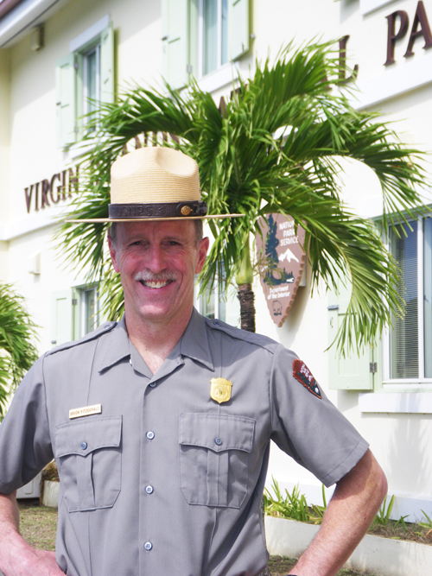
VINP’s new top brass is Brion FitzGerald, above.
Brion FitzGerald took over the reigns of the V.I. National Park last week facing a tight budget made even more grim as the National Park Service faces sequestration cuts.
VINP, out of all Southeast Region NPS sites, has likely been waiting the longest for an operational funding increase, FitzGerald explained.
“This park has not had an Operational Fund increase since 2001 and that is amazing,” he said. “I doubt there is another park in the entire region that has waited so long for an increase. That is a huge deal.”
“Without operational fund increases you can’t fill jobs when they become vacant,” said FitzGerald. “That leads to slow and steady erosion of park staff. And sequestration is another nail in the coffin.”
Despite being “unrealistic,” increasing VINP’s operational budget in an effort to fill about 20 vacant positions in VINP is FitzGerald’s number one goal, he said.
The new VINP Superintendent’s number one priority, however, is supporting his staff.
“My biggest priority is to help staff do their jobs,” he said. “That’s my job.”
FitzGerald brings 34 years of experience with NPS to his VINP Superintendent post. As an East Carolina College student majoring in Park Management, FitzGerald followed a whim to an internship in Great Smoky Mountains National Park in 1978, where he met his future wife.
The North Carolina native was smitten with NPS work as well as his wife Mary Robinson, a former NPS employee herself.
Having worked at Joshua Tree National Park, Gulf Islands National Seashore, Saguaro National Park, Everglades National Park and Assateague Island National Seashore, FitzGerald was appointed Chief of Interpretation, Protection and Museum Services at Gettysburg National Military Park in 1995.
The move to VINP will likely be his final post, FitzGerald, on the verge of 57, explained.
“I honestly don’t know how long I will be here, but somewhere in the neighborhood of four to five years,” he said. “This is my last job.”
FitzGerald actually planned to retire in Gettysburg, having no intention of relocating before the VINP Superintendent position became available, he explained.
“I was not looking for another job; I planned to retire in Gettysburg,” said the new VINP Superintendent. “We’ve always loved the Caribbean and we came to St. Thomas for our 25th wedding anniversary in 2006. We spent a day on St. John and then came back in 2011 and spent 10 days.”
Driving back from a missionary trip in South Dakota last summer, FitzGerald heard a Jimmy Buffet song on the radio which got him dreaming of being near the water again.
“I had a mind shift and thought, ‘I could do this,’” he said. “When I returned I found out that Mark Hardgrove had retired and it all fell into place. This was the only place I’d even consider applying for a job.”
“We want to live on St. John and spend time getting to know this special park,” said FitzGerald.
FitzGerald looks forward to working more with Habitat for Humanity and taking mission trips with his Pennsylvania church after retiring. Before then, however, he’ll face the VINP’s shrinking budget as he strives to work along with the St. John community.
“I plan to work with the community to come to common terms on park issues,” said the new VINP Superintendent. “We will work to see how we can cooperate for the shared benefit of our resources for visitors and the community at large.”
He’ll have to do that with a five percent reduction in NPS funding, although he expects to avoid any furloughed employees as do most NPS sites. The biggest impact on VINP from sequestration will be the vacant positions which cannot be filled and impacts from a lack of staff, like shutting the Visitors’ Center one or two days per week, FitzGerald explained.
“We’re looking at long-term deterioration,” he said. “You won’t see the wear and tear on our employees who are doing the jobs of two or three people, but it will be there.”
Getting back to his top priority of supporting the VINP staff, FitzGerald will place employee safety above all other concerns, he explained.
“We will do the best job we can with the resources that we have,” said the new VINP Superintendent. “The NPS is in the habit of asking employees to do more with less. We are at the point now to decide what are the critical things we have to do.”
“It’s possible we might have to close the Visitors Center one or two days a week and reduce some programs,” he said. “What I am not going to do is work my employees to death to keep up with projects they can’t safely complete.”
“If there is a situation and you need two rangers to patrol but you only have one, then you don’t patrol,” said FitzGerald. “If you can’t safely do something, it won’t be done. We won’t let people get hurt.”
Having lived on remote islands before, FitzGerald is fully aware of the dangers of hurricanes and the unique situations faced when the mainland is miles away.
“I respect storms,” he said. “One goal here is to get everything done at VINP so our employees can go home and take care of their families.”
FitzGerald is also a Commander in the U.S. Coast Guard Reserves, for which he has served 22 years as an enlisted member and officer including a one year tour in the Persian Gulf.
His wife Mary is due to arrive on St. John shortly, as he settles into island life with his 18-year-old daughter Katie. FitzGerald also has two sons, one living in Florida and the other in Pennsylvania.
The new VINP Superintendent has already spent time meeting with staff members and department heads and is impressed with the crew.
“I’m very impressed with the park staff here and their ability to get everything done,” said FitzGerald. “There are a lot of people in this park working their butts off and they deserve more recognition.”

